April 2020 Newsletter

Office Hours
The office is open from 8:00 a.m. to 3:00 p.m. on Monday, Tuesday, Thursday, and Friday.
Office phone number is 972-442-6875 Email: District@slud.us
Upcoming Meetings
Board meetings are held on the third Monday of each month @ 7:30 p.m. in the Seis Lagos Community Clubhouse. The meetings are open to the public and we welcome you to attend.
E-Billing Notifications
E-Billing saves time, paper and money by emailing residents their Utility Bill. Please sign up for E-Billing by emailing SLUD at District@slud.us *Include your name, address, and contact information.

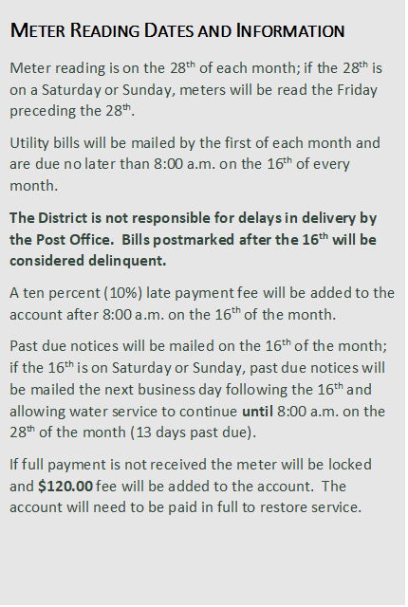
Payment Methods:
- Pay by check via mail or the drop box by the clubhouse.
- Use ACH –Direct Withdrawal
- Online payment system on the SLUD website at http://www.slud.us/bill-payment.
- Drop off payment at the SLUD office.
- Automatic Bill Pay - For more details contact the SLUD office
- We can now accept debit/credit card payments over the phone during normal office hours.

SWIMMING POOL INSTALLATION AND CONSTRUCTION REMINDER:
If you have installed a swimming pool within the past 2 years and did not contact SLUD prior to construction, please contact our office to schedule an inspection. You are subject to disconnection of service and your meter pulled out of the ground. We require that you complete a Contractor Permit & Deposit Agreement at the business office prior to any construction commencing. A deposit of $2,000.00 is required (refundable “if” the road is not damaged), as well as a non-refundable inspection fee of $60.00
Utilization of concrete trucks, eighteen (18) wheelers, dump trucks or heavy equipment require a Contractor Permit & Deposit Agreement and a deposit of $2,000.00 prior to commencing any work. Roads will be inspected prior to any work commencing and a final inspection of the road will be assessed upon completion of your project. If there is no damage to the road, a check will be issued by SLUD for a full return of the deposit. Please allow no less than seven (7) business days for your refund check to be processed. If any work proceeds without meeting these requirements, a non-refundable charge of $3,000.00 be issued (individual charge of $3,000.00 per lot if multiple lots). This information may be found in the Rates & Rules, Sections 6.8. and 5.1.

